

e-Rx Column Symbols & Definitions

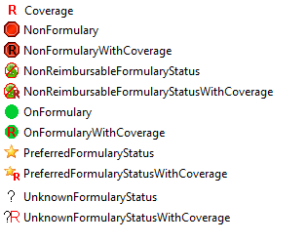 | Coverage – The medication has coverage restrictions.  NonFormulary – The medication isn't on the patient’s insurance formulary list  NonFormularyWithCoverage – The medication isn't on the patient’s insurance formulary list and has coverage restrictions.  NonReimbursableFormularyStatus – The medication isn't on the patient’s insurance formulary list and won't be reimbursed at all.  NonReimbursableFormularyStatusWithCoverage – The medication isn't on the patient’s insurance formulary list, won't be reimbursed at all, and has coverage restrictions.  OnFormulary – The medication is on the patient’s insurance formulary list.  OnFormularyWithCoverage – The medication is on the patient’s insurance formulary list and has coverage restrictions.  PreferredFormularyStatus - The medication is on the patient’s insurance formulary list and is preferred. A “+” sign followed by a number in the image represents the amount of preference; higher numbers signify higher preference.  PreferredFormularyStatusWithCoverage - The medication is on the patient’s insurance formulary list, is preferred, and has coverage restrictions.  UnknownFormularyStatus – The insurance formulary status is unknown (probably because the patient’s insurance is unknown).  UnknownFormularyStatusWithCoverage – The insurance formulary status is unknown and medication has coverage restrictions.

